**Setting up Working Directory in R Studio.**

First – you should create a Working Folder (called “Working Direct” in R Studio) for R and other files that you will use in the Programming for Big Data module. Choose you own name and file path for this Directory.

In the **Files** panel of R Studio, note the three dots on the right side pointed out by the red arrow below – click on this:

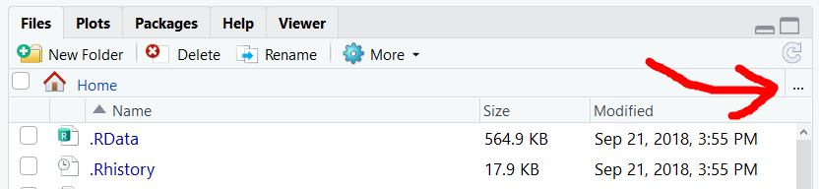

Browse to the new folder that you have just created – this will be different for each student. IN the example below – all files are stored in the **R Code** directory:

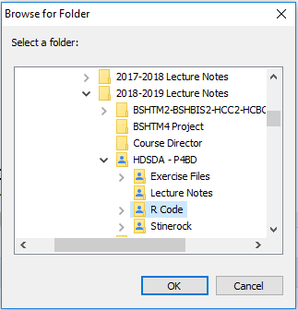

The list of files displayed will change to list those in your Working Directory:

Next – click on the **More** or blue cog Settings option as highlighted below:

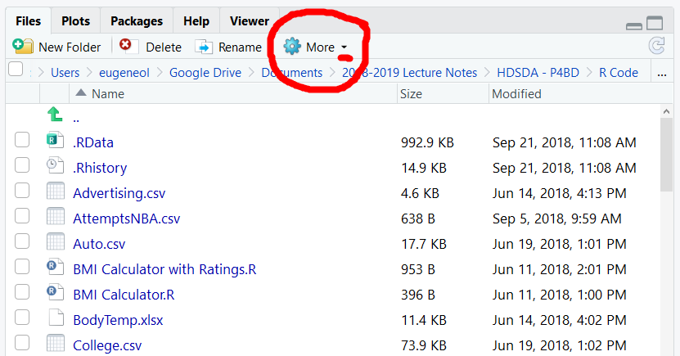

The following drop down menu appears:

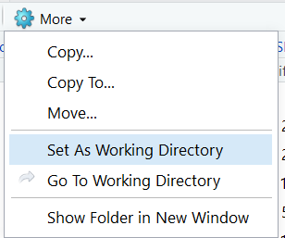

Select **Set as Working Directory** and now R Studio will by default select files from this Directory/Folder.

**\*\*\*\*\* NOTE – YOU WILL NEED TO DO THIS EVERYTIME YOU START/RESTART R STUDIO \*\*\*\*\***